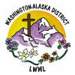
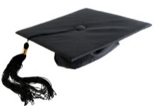
Aid to Washington-Alaska District Scholarship Fund
$15,000
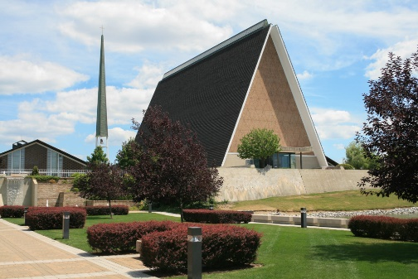
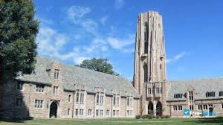
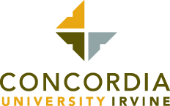
Concordia Theological Seminary Concordia Seminary Mission Training Center
Fort Wayne, Indiana St. Louis, Missouri Irvine, California

Scholarship Recipients for the 2022-2023 Academic Year
Four applicants for scholarships from the LWML Washington-Alaska District were approved by the Executive Committee. All recipients are planning to become full time church workers and are enrolled in Missouri Synod Seminaries or Concordia University programs. The home congregations for each of these recipients are located within the district.
Reverend Matthew Both is enrolled in the Mission Training Center in Irvine, California. He is currently working with Ethiopian and Sudanese people in Renton. He hopes to improve both his English and his knowledge of Lutheran theology so he can teach God’s word clearly and correctly.
Justin Chester will be attending his second year at Concordia Theological Seminary in Fort Wayne, Indiana. He plans to become a minister. His home church is Messiah Lutheran Church in Marysville, Washington. Justin is married and has two young children.
Grace MacDuff’s home church is Bethlehem Lutheran Church in Kennewick, Washington. She will be attending her second year at Concordia Seminary in
St. Louis, Missouri, taking on-line courses. Grace is an active member of the LWML. She is studying to become a deaconess.
Benjamin Oesch will begin his second year at Concordia Seminary in St. Louis, Missouri. His home church is Messiah Lutheran Church in Marysville, Washington. He intends to become a minister.
2022-2024 Biennium – LWML Washington-Alaska District

